**KNOW BEFORE YOU GO**

We’re excited to see everyone this year at the 2024 NASW Chapters Conference: A Meeting of the Profession taking place Thursday, November 7 & Friday, November 8, 2024. To help you prepare for this LIVE VIRTUAL event, we’ve put together this document so you can show up at the conference ready to learn, grow, and connect with other professionals in your field.

# Pre-Conference Check-In

This year’s live virtual conference will be hosted again via Zoom Events. In order to ensure that everything runs as smoothly as possible on the day of the event, we ask that you please complete the pre-conference check-in steps below ASAP. Due to limited staff availability on the day of the event, we ask that all registrants complete the pre-conference check-in ASAP to verify access to conference in Zoom Events *before* November 1st to allow time for troubleshooting.

When registering for the conference, we asked you to provide the e-mail address you use to access Zoom. This is because this e-mail address has been pre-registered to gain access to the event. In the event that you log into [Zoom Events](https://events.zoom.us/) and do not see the 2024 NASW Chapters Virtual Conference logo, see our “Troubleshooting” section further below.

To Complete the Pre-Conference Check-In:

1. Go to [NASW Chapters Conference Login](https://events.zoom.us/ev/Ar4ZAbqeHdDV4EDHWu8HKwi2ImTPFAf8y9U6VZcbhJuYSzuL1vYO~AnPVbfneOIGMw5n3SSo5SQzBiKVcceehyRwIpYsCeaIiTXLFQ_p5xk-xFQ) page.
2. If you are already logged into the Zoom Account where your e-mail matches the e-mail you used to register you should see a join button (click join) otherwise you should see the below image.

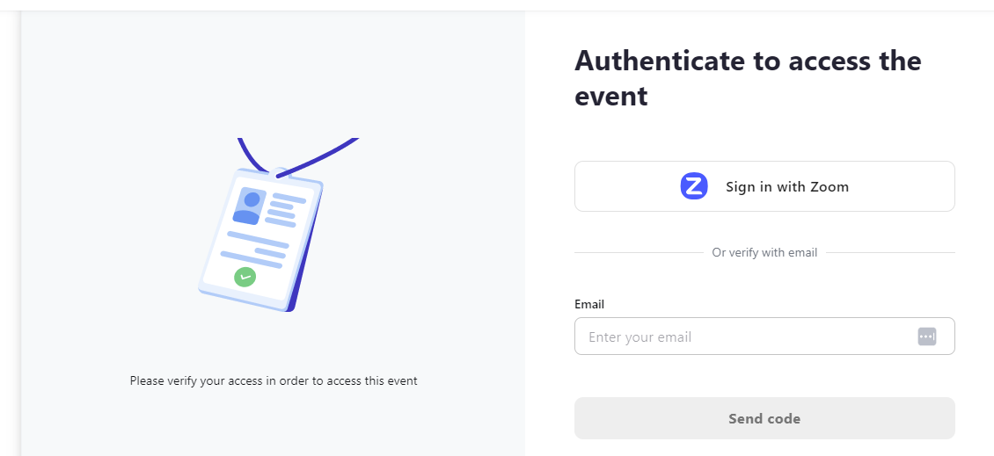

1. You have two options: the best option is login to your Zoom account that matches the e-mail you used to register. The second option is you can type the e-mail you used to register for the conference and click send code. This will send a code to your email which you will need to input on the next screen to verify before being able to login to the conference. (it may take a few minutes to get the code – if you don’t receive it there is a button to resend). **We STRONGLY encourage you to use the zoom login option as you will have more interactive features available to you.**
2. Note: If the email you used to register is not affiliated with your Zoom account, you can always sign up for a FREE zoom account using this different e-mail address to gain all of the platform features during the conference.
3. If, after attempting to log in, you receive a registration link telling you the e-mail you are using or the e-mail associated with your Zoom account wasn’t the email you used to sign up for the conference, go back and find your conference confirmation e-mail and log in using the e-mail address you provided as your Zoom account e-mail.

**Troubleshooting**

Logged in but don’t see the **Join Lobby** button? The Zoom account e-mail address you provided at registration will need to match the e-mail you use to log into Zoom Events. You can either 1) Sign up for a free Zoom account with your registration e-mail, or 2) Sign out of whatever Zoom account you are logged into and log back into Zoom account that matches the Zoom account e-mail you provided at registration (check your confirmation e-mail). 3) Use the send the code option.

Other issues may be that you don’t know your login for Zoom or that you are logged into another Zoom account. First, log out of the Zoom account you’re currently logged into, then search all of your e-mail accounts for a confirmation e-mail from Zoom or Wufoo for the conference. This will be the e-mail you registered with and with which you will need to log into Zoom Events. If you don’t know your password for this account, click on the “Forgot password?” on the Zoom Events login page to help you reset your password.  

**Navigating the Zoom Events Platform**

When you’ve logged into the Lobby, take a look around and explore the different tabs via the menu at the top of the page:

* See all of this year’s education offerings by clicking on the **Sessions** tab. Click on the bookmark logo to the right of the session to save a training to your personal **Itinerary**.
* Check out our conference sponsors under the **Sponsors** tab.
* Check our conference speakers under the **Speakers** tab.
* Wanna see who’s attending? Click on the **People** tab.

Customize your profile by clicking your profile icon in the upper right corner, then clicking the blue pencil (edit button).by adding your photo, name, job title, and place of employment.

Additionally, feel free to leave a message in the Main Lobby Chat introducing yourself and telling us what you’re most looking forward to at this year’s live virtual conference!

# General Conference Information

**Date**: Thursday, November 7 & Friday, November 8, 2024

**CEUs Available**: Up to 8.0 CEUs

**Event Platform**: Zoom Events

**Recommended Login Time**: We recommend logging in at least 15 minutes before the conference start time each day to ensure that all audio and visual components are working and technology is updated and ready before conference start time.

## Conference Duration

**Times**: Times are the same for both days.

* 11:00am to 4:00pm Central Time
* 10:00am to 3:00pm Mountain Time
* 9:00am to 2:00pm Pacific Time

## Conference Session Handouts

To find session handouts, go to **Session** and click on the session name. Scroll down past the *Speakers* and *Description* to see if a *Files* section has been added. If a presenter has provided handouts for their session, it will be uploaded here. If there are no materials for a workshop available, you can also contact the speaker directly to see if they can make their materials available. Remember to check back closer to the date of the conference as well as afterwards as materials may not yet have been made available by presenters.

## Attire

Suggested attire is business/business casual for the conference as you may be on camera for group work or speaker discussions.

## Session Recordings

One of the most frequently asked questions we get about the conference is whether the sessions will be recorded for later viewing? In short, where permitted by presenters and the event platform, some of the conference sessions will be recorded and be available for purchase in early 2025 through the [Social Work Online CE Institute](https://naswinstitute.inreachce.com/SearchResults?productAttribute=62FA7ECF-495C-45F7-B799-7443DD7B216E).

Attending Sessions.From the Conference Lobby, click on the **Sessions** menu to view all courses. Due to the flexibility of the event platform, you are able to attend any session you wish without need of pre-selecting the sessions. That is, if you wanted to pre-register yourself for a particular session, there is no need as all sessions will be available to all attendees. You can click the flag icon next to the session if you want to make an itinerary for the day of. To attend sessions on the day of the event, go to **Sessions** and click **Join**. You can also click on the name of the session to see speaker names, read a full description of the session, and download any course materials (if available).

# Education and CEUs

Please be sure log in early on the day of the conference and to stay through to the end.

While we understand there are many extenuating circumstances that may attribute to a late arrival or a missed session, we can only issue CEU hours for time you are actively in attendance of the conference. Therefore, if you require the full day of CEUs, make sure to arrive early each, stay through to the end of the conference, and stay present at your computer. A failure to complete these requirements may result in deducted CEU credits. See “How Do I Earn and Get My CEUs?” for full details on obtaining your CEUs.

## How Many CEUs Can I Earn?

Participants attending this year’s 2024 NASW Chapters Virtual Conference are eligible to receive up to 8.0 continuing education units (CEUs) for attending the entire two-day conference in full.

Of those CEU hours, there is the potential to earn CEUs fulfilling requirements for clinical supervision, cultural competency, or implicit bias in Illinois, or diversity, equity, and inclusion (DEI) or suicide prevention in Nevada. To get credit for these hours, make sure that you attend that session in full and select that session on the end of the conference survey and questions.

## How Do I Earn and Get My CEUs?

Please note that our steps for earning your CEUs has changed.

* *Stay Logged In and Actively Engaged***.** Sign into the Zoom Events on time, stay actively engaged in the sessions (i.e., do not minimize the screen to do work in another window or walk away from your computer), and remain logged in until chapter staff announce the conclusion of the conference.
* *Take Notes on the Sessions You Attended.* You willbe tested on the knowledge you gained from the course as well as how it can apply to your career or practice. We strongly encourage you to take notes of the session you attended and what you’ve learned so that you can refer back to them and remember what was covered upon conclusion of the conference.
* Immediately upon conclusion of the conference, you will receive a link to complete our post-conference exam and evaluation via SurveyMonkey*. Complete the post-event survey and exam which will be sent out via SurveyMonkey. Select the sessions you attended and complete the exam questions. You will need to complete all questions and click submit at the end. *It is critical that you complete the survey within 5 business days*.
* *Wait 45 days for CEU certificate to be sent.* While the chapter strives to send CEU certificates out as soon as possible, it does take some time to review answers to questions and verify attendance via Zoom analytics.

*\*Don’t see the survey from SurveyMonkey in your e-mail?* If you do not receive the conference survey after the conference, be sure to check your e-mail’s spam folder. Additionally, check with your network administrator to make sure e-mails from us or SurveyMonkey are not being automatically blocked by the system.

If you have checked your e-mail’s spam folder and still cannot locate the e-mail from SurveyMonkey, please make sure you have not opted yourself out from receiving e-mails from SurveyMonkey. You can opt back in here: <https://www.surveymonkey.com/user/email-opt-in/>. Once you’ve done so, let us know and we will resend the survey link to you.

## How Do I Earn My CPDUs (for PEL-holders)? (Illinois licensees ONLY)

If you registered to receive CPDUs at registration and do not hold an LSW or LCSW, you should have received a link to the ISBE evaluation form required to receive CPDUs. You will need to complete this form upon completion of the conference and e-mail it to NASW-IL to receive CPDUs. Please allow 45 days to receive your CPDUs by e-mail as they need to be customized for each individual. If you hold a PEL and an LSW or LCSW, you can use the CEU certificate from the conference for your LSW/LCSW renewal and do not need CPDUs.

## When/how will I get my CEU/CPDU certificate?

**ALL CONFERENCE CEUS WILL BE E-MAILED WITHIN 45 DAYS OF THE CONFERENCE.**

**Please refrain from e-mailing the chapter about the status of your certificate as it will slow down our work to process your certificates as quickly as possible. Be sure to check both your e-mail marketing, spam, and junk folders for your certificate.**

Participants are responsible for providing current contact information when completing the survey for the conference. The NASW Chapters will be issuing CEUs via e-mail and is not responsible for CEUs that are not received by conference participants if contact information is not current. This year’s NASW Conference workshops will qualify as continuing education for the following professions*:

* In Illinois: LSWs, LCSWs, PELs, LPCs, LCPCs, LMFTs, RNs, LPNs, APNs, and LCPs.
* In Nevada: Professionals licensed by Nevada Board of Examiners for Social Workers, Nevada State Board of Psychological Examiners, State of Nevada, State of Nevada Board of Examiners for Marriage and Family Therapists & Clinical Professional Counselors, Department of Education.
* In North Dakota: Professionals licensed by the North Dakota Board of Social Work Examiners.

*\*Subject to change​*

# Licensure Questions

If you have any questions about licensure or CEU requirements, please visit your local NASW state chapter website and/or licensing board for more information:

*ILLINOIS*

NASW-IL: <https://www.naswil.org/licensure>

Illinois Department of Financial & Professional Regulations (IDFPR): <https://idfpr.illinois.gov/Contact/IDFPRContact.asp>.

*NEVADA*

NASW-NV: <https://naswnv.socialworkers.org/Professional-Development/Licensing>

Nevada Board of Examiners for Social Workers: <https://socwork.nv.gov/>

*NORTH DAKOTA*

NASW-ND: <https://naswnd.socialworkers.org/>

ND Board of Social Work Examiners: <https://www.ndbswe.com/>

# Further Conference Questions

Contact us by e-mail: [office.naswil@socialworkers.org](mailto:office.naswil@socialworkers.org).

# NASW-IL, ND, and NV Policy on Hostile Conduct/Harassment

The NASW-Illinois, North Dakota, and Nevada Chapters seek to provide an educational environment in which diverse participants may learn, network, and enjoy the company of colleagues in an environment of mutual human respect. We recognize a shared responsibility to create and hold that environment for the benefit of all. Some behaviors are, therefore, specifically prohibited:

* Harassment or intimidation based on race, religion, language, gender, sexual orientation, gender identity, gender expression, disability, appearance, or other group status.
* Sexual harassment or intimidation, including unwelcome sexual attention, stalking (physical or virtual),
* Threatening attendees, speakers, staff, or volunteers.

Speakers are asked to frame discussions as openly and inclusively as possible and to be aware of how language or images may be perceived by others. Participants asked to stop a hostile or harassing behavior are expected to comply immediately. Conference participants seek to learn, network, and have fun. Please do so responsibly and with respect for the right of others to do likewise.

Attendees found to be behaving in a manner counter to these policies will be removed from the conference/virtual platform without a refund.

If an incident occurs and you wish to file an anonymous harassment complaint, you can do so at: <https://naswil.wufoo.com/forms/anonymous-harassment-form-naswil-event/>